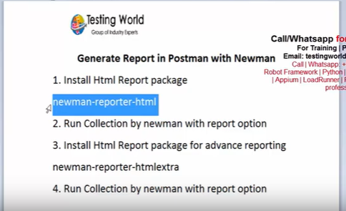

npm install -g newman-reporter-htmlextra

Export the collection from the postmen tool.

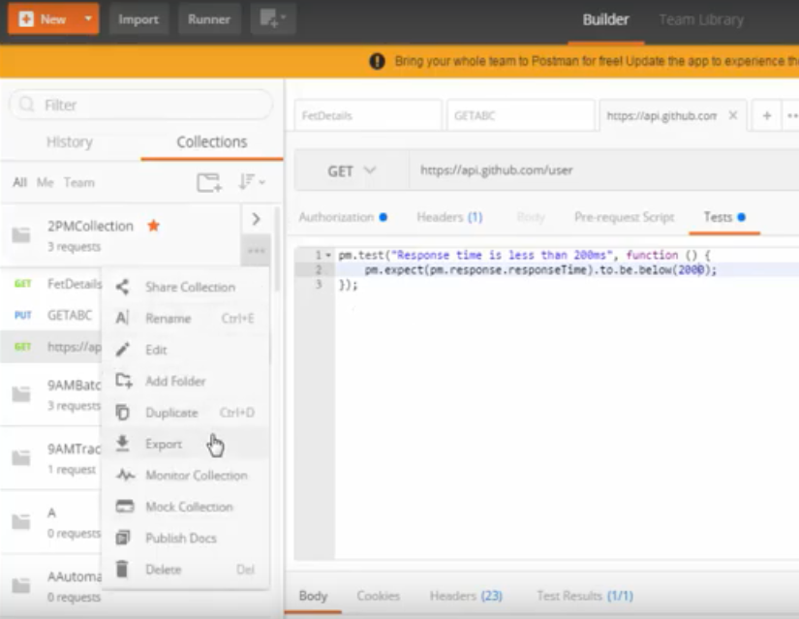

Save it any where.

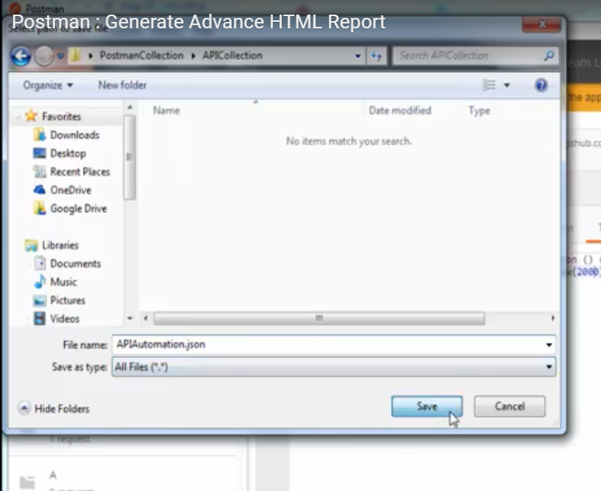

Go to command promt and go to the collection path.

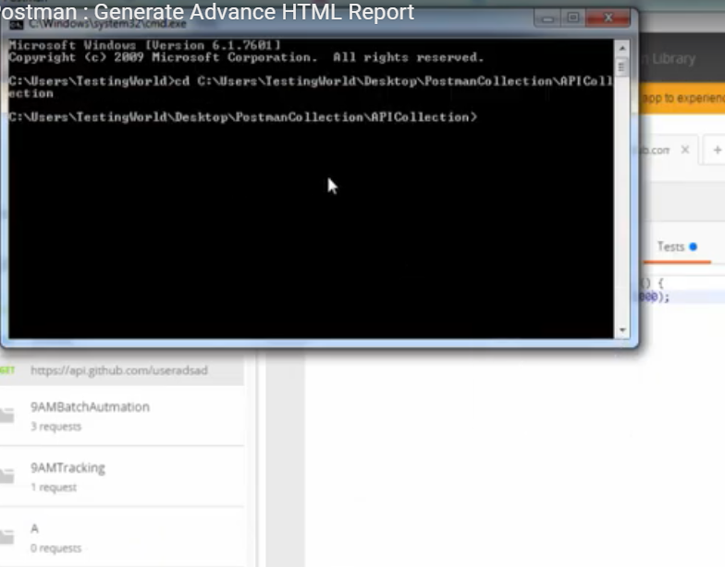

Run the command below.

newman run apiautoamtion.json

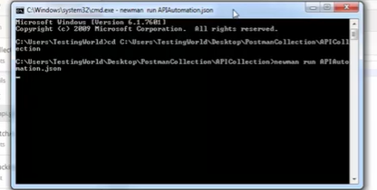

The report is generated as below

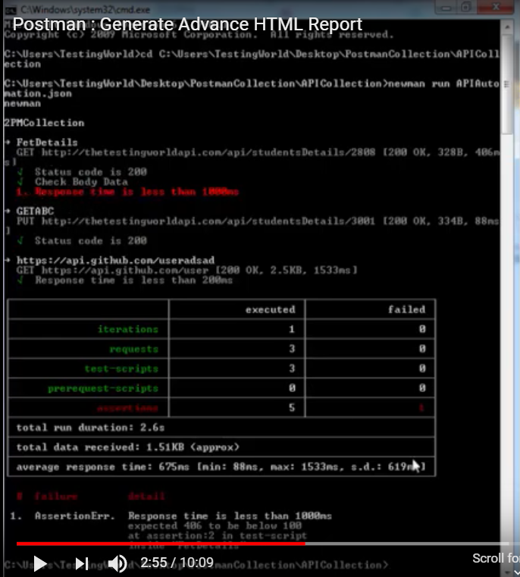

To generate the reports in html or pdf we need to install newman-reporter-html



To install the newman-reporter-html go to command prompt run the below command

npm install –g newman-reporter-html

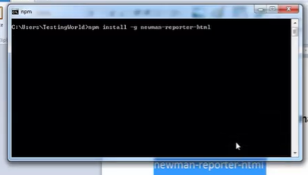

Once install the newman-reporter-html go the path and execute the command below.

newman run APIAutomatio.json –r html

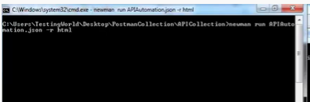

Once execute the command.go to the apipath and observe the newman folder is created.

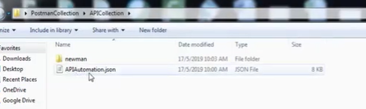

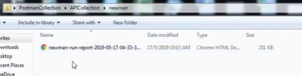

Then open the report

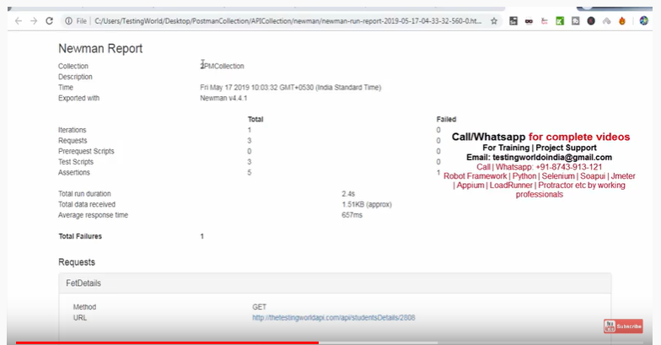

It is looking bad to see so we need to see in tsbles and colours .

We need to install newman-reporter-htmlextra

Go to command prompt and run the below command

npm install –g newman-reporter-htmlextra

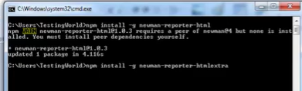

Once install run the below command

newman run APIAutomatio.json –r htmlextra

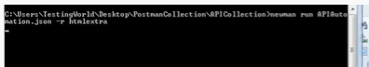

After that the report is generated .open the report

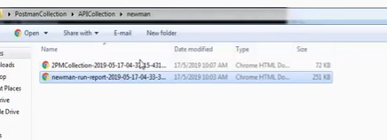

The report is below

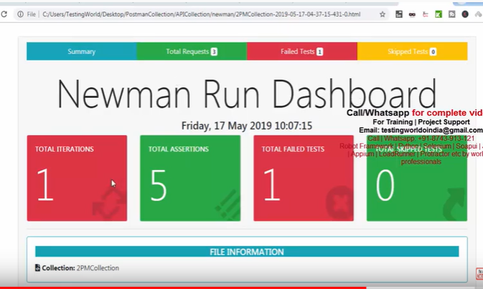

If you want to run it multiple times you need to run the below command

newman run APIAutomatio.json -n 3 –r htmlextra

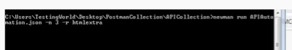

Here 3 is the number of iterations. The report is below

